Branch/Class/Batch: AIDS TE A1
Student Roll no. A29
Student Name: Aryan Talekar
Assignment 1:
Network Topology and Media Simulation

1. Client-Server Socket Programming

Aim
To implement a simple client-server network architecture using Python socket programming, where a client sends a text message to a server and receives a response.

Objective
The objective of this experiment is to understand the basic concept of client-server communication using socket programming. The client establishes a connection with the server, sends a text message, and receives an acknowledgement from the server.
Theory

Socket Programming
Socket programming is a method of communication between two computers or processes over a network. A socket acts as an endpoint for sending and receiving data.
In this experiment, a TCP socket is used to establish reliable communication between a client and a
server.
Client:
The client initiates the connection with the server and sends a message.
Server:
The server waits for incoming connections, receives the client's message, and sends a response.
IP Address:
The program uses 127.0.0.1, which is the loopback address representing the local computer.
Port Number:
Port 5000 is used for communication between the client and server.
TCP:
TCP (Transmission Control Protocol) provides reliable, connection-oriented communication.

Algorithm

Server Algorithm
- Import the socket module.
- Create a TCP socket.
- Assign the IP address 127.0.0.1 and port 5000.
- Bind the socket to the specified IP address and port.
- Start listening for client connections.
- Accept the client connection.
- Receive the message sent by the client.
- Display the received message.
- Send a response to the client.
- Close the client and server sockets.

Client Algorithm
- Import the socket module.
- Create a TCP socket.
- Specify the server IP address and port.
- Connect to the server.
- Accept a message from the user.
- Send the message to the server.
- Receive the server's response.
- Display the response.
- Close the client socket.

Network Architecture
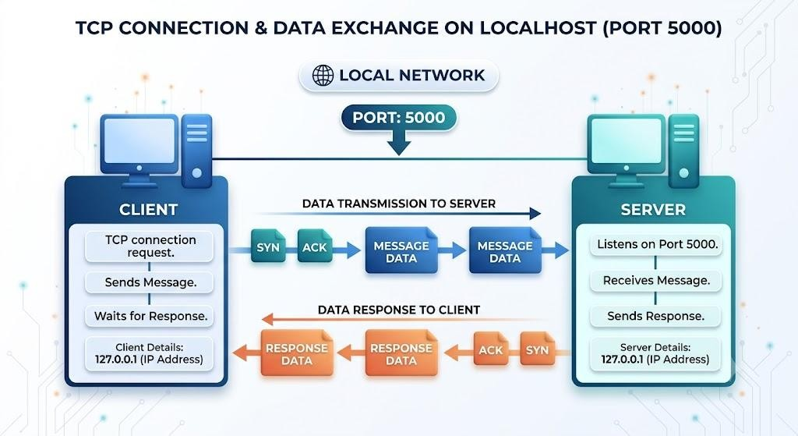

SOURCE CODE

Server Program
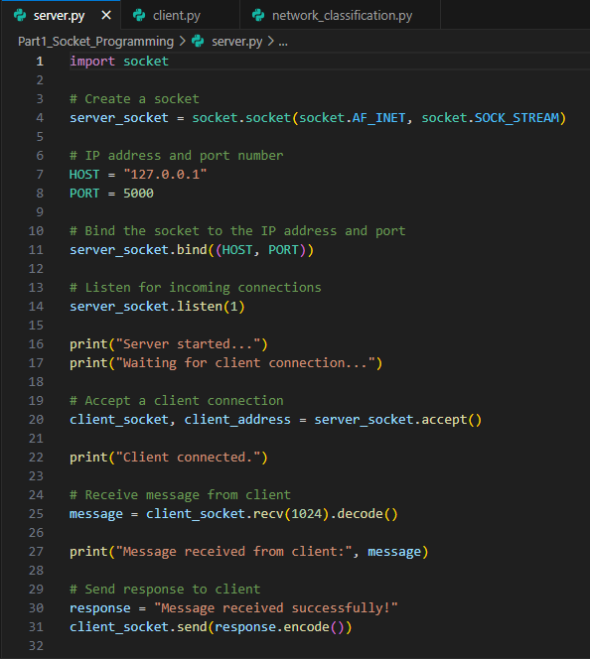

Client Program
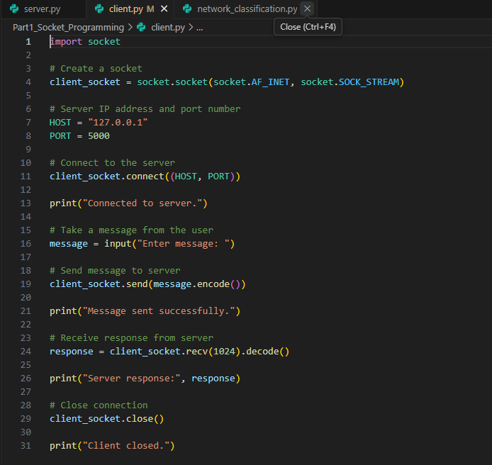

OUTPUT
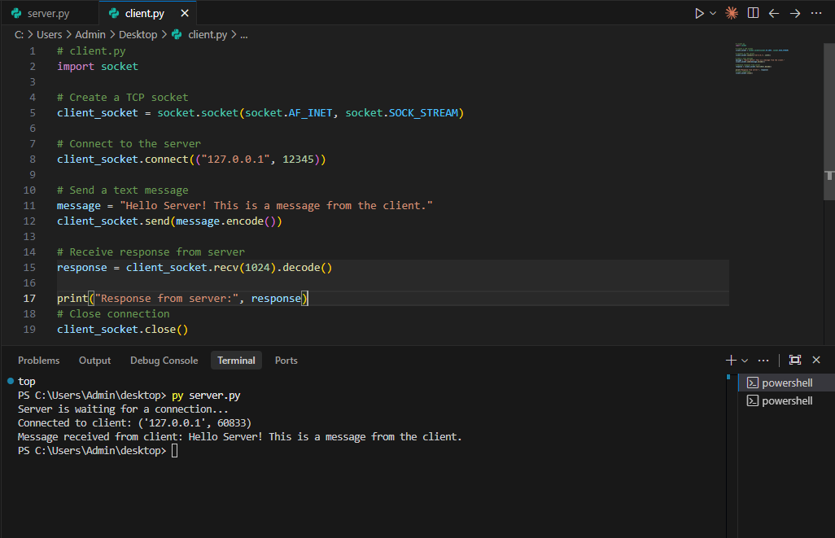
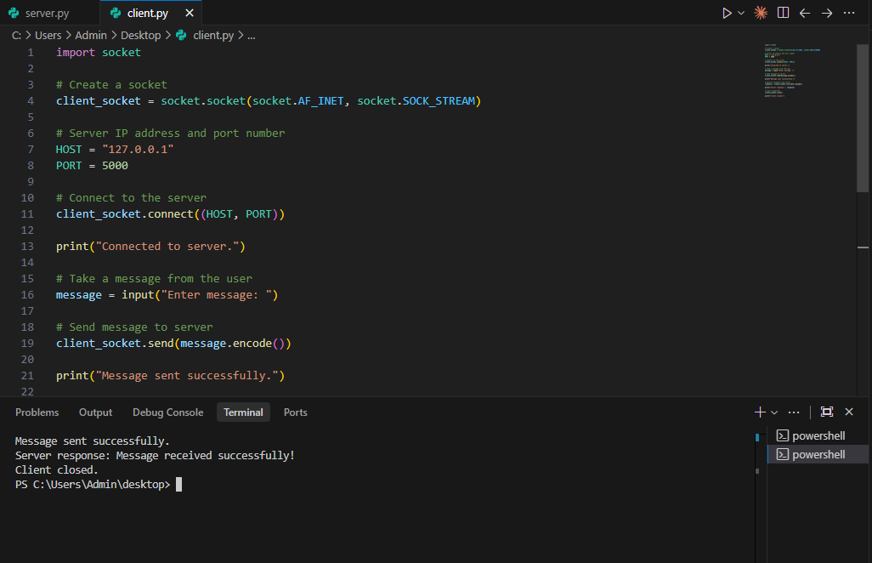

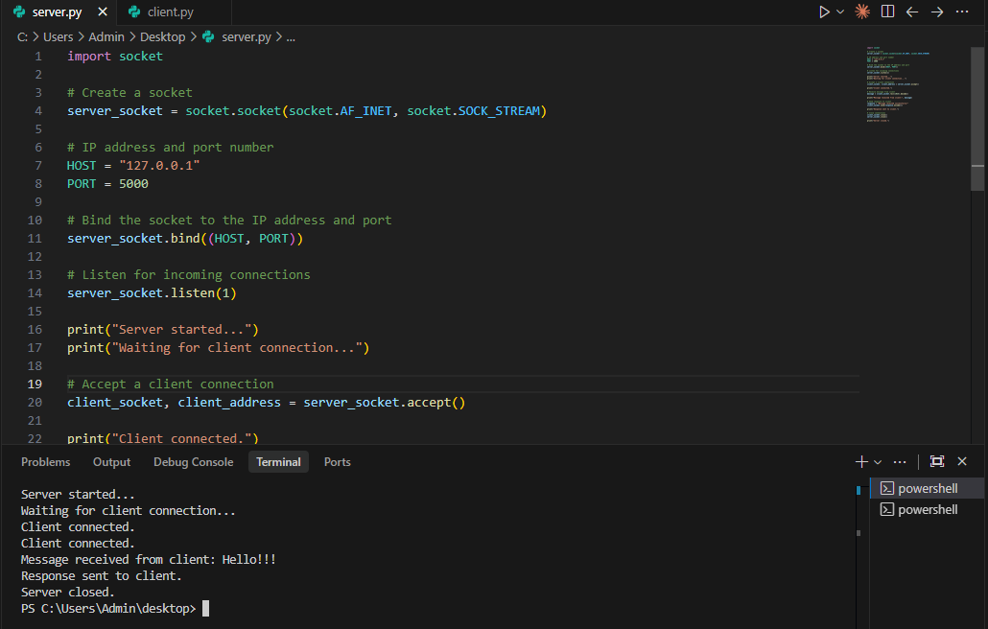

Result
The client-server architecture was successfully implemented using Python socket programming. The client established a TCP connection with the server using the loopback IP address 127.0.0.1 and port 5000. The client successfully sent a text message to the server, and the server successfully received the message and returned a response.

2. Network Device and Transmission Media Classification

Aim
To develop a Python program that classifies common network devices and transmission media based on their OSI layer, type, and primary function.

Objective
The objective of this experiment is to understand the role of common networking devices and transmission media in a network topology and classify them according to their layer of operation and primary function.

Theory Switch
A switch is a networking device primarily operating at Layer 2 – Data Link Layer of the OSI model. It connects multiple devices within a LAN and forwards frames using MAC addresses.

Router
A router operates primarily at Layer 3 – Network Layer. It connects different networks and forwards packets based on IP addresses.

Bridge
A bridge operates at Layer 2 – Data Link Layer. It connects and filters traffic between two LAN segments.

Access Point
An access point primarily operates at Layer 2 – Data Link Layer and provides wireless connectivity between Wi-Fi devices and a wired network.

Transmission Media
Twisted Pair Cable
Twisted pair is a wired transmission medium commonly used for Ethernet and LAN connections.
Coaxial Cable
Coaxial cable is a wired medium used for cable television, broadband and data transmission.

Fiber Optic Cable
Fiber optic cable transmits data using light and provides high-speed communication over long distances.
Wireless/Radio
Wireless transmission uses radio waves for communication. Wi-Fi is a common example.

Classification Table
Device/Media | Layer/Type | Primary Function
Switch | Layer 2 – Data Link | Connects devices within a LAN
Router | Layer 3 – Network | Connects different networks
Bridge | Layer 2 – Data Link | Connects LAN segments
Access Point | Layer 2 – Data Link | Provides wireless connectivity
Twisted Pair | Wired | Ethernet/LAN connections
Coaxial Cable | Wired | Broadband/cable transmission
Fiber Optic | Wired | High-speed long-distance transmission
Wireless/Radio | Wireless | Wi-Fi and wireless communication

SOURCE CODE
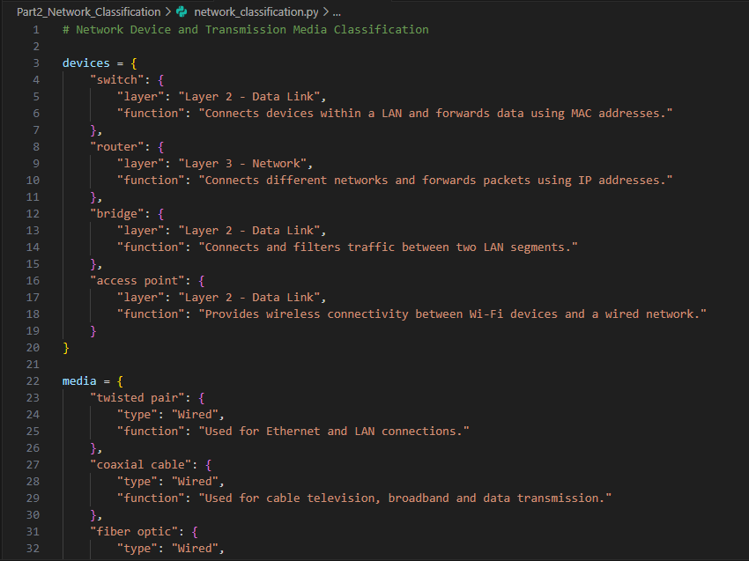
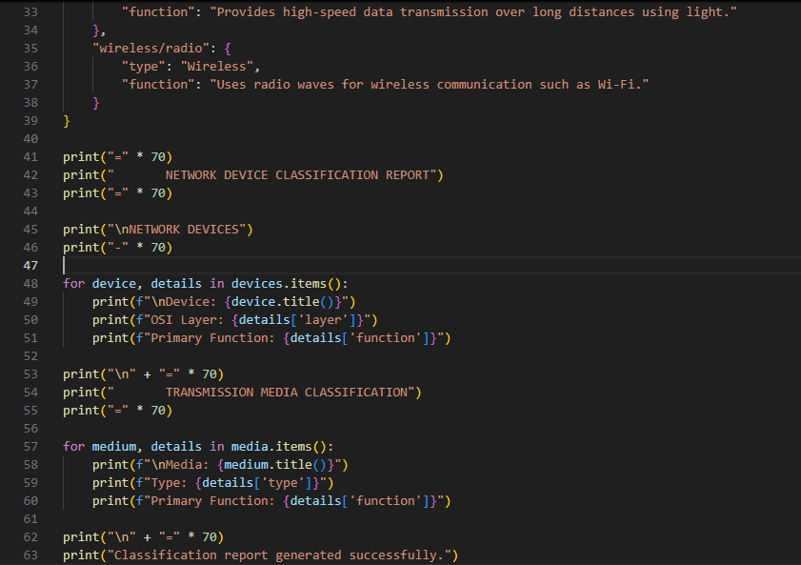

Output
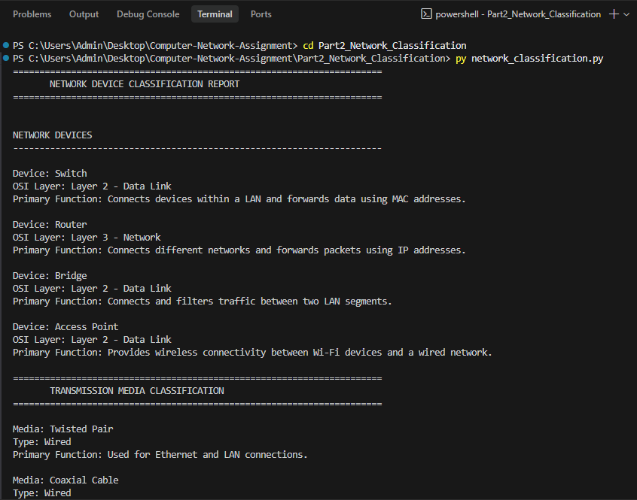

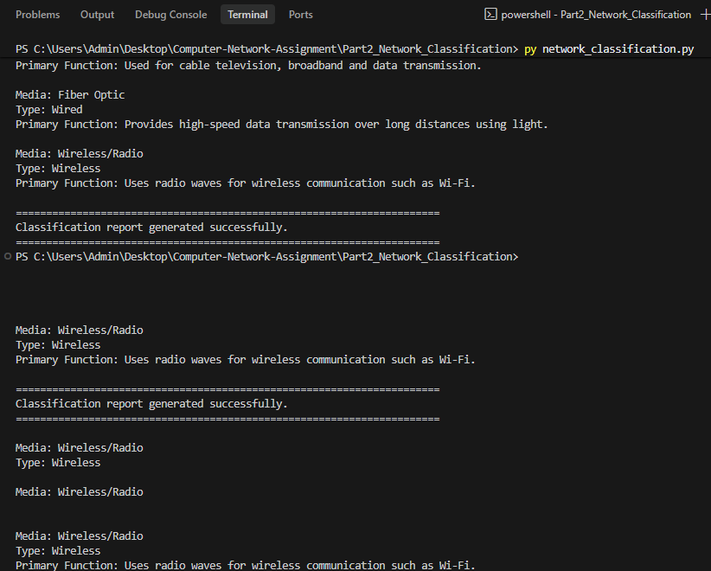

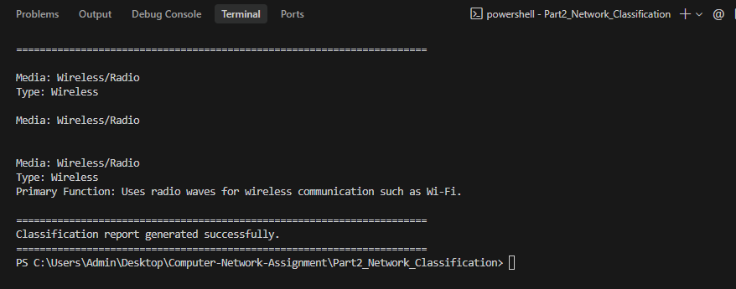

Result
The Python program successfully classified the given network devices according to their OSI layer and primary function. It also classified different transmission media based on their type and application.

Conclusion
Through this assignment, the basic concepts of computer networking and network communication were studied and implemented. A client-server architecture was successfully created using Python TCP socket programming. The communication between the client and server demonstrated the process of establishing a connection, sending data, receiving data, and terminating the connection. Additionally, common network devices and transmission media were classified according to their network layer, type, and primary function.

